Name : |  | 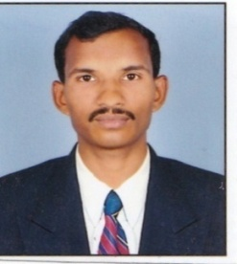  RAKESH MADHUKAR KAPGATE
Designation | : | ASSISTANT PROFESSOR
Qualification | : | M.Sc Agri.
Department | : | Animal Husbandry and Dairy Science
Specialization | : | Animal Husbandry
Academic Profile | : | M. Sc Agri. : Conceded First Class from Dr.Balasheb Sawant Konkan Krishi Vidyapeeth Dapoli. Dist-Ratnagiri  (Maharashtra State)  B. Sc Agri. : Conceded Second class from Anand Niketan College of Agriculture, Warora Dist- Chandrapur Affiliated by Dr. P. D. K.V. University, Krishinagar Akola.
Working Experience | : | - Working as Assistance Professor in K.V.Patel college of agriculture shahada since 15th July 2014 to still today (location: Maharashtra)
Research Activities | : | M. Sc. Research Title “ Effect of Thatching Material on Physiological Responses of Konkan Kanyal Goats In Summer’’ Guided by Prof. N.N. Prasade Assistant Professor, Department of Animal Husbandry& Dairy Science, Dr B.S.K.K.V Dapoli.  Seminar Presented “Cloning in Animals and its Applications”
Research Publications | : | International :02  National :03
Popular articals | : | 06
Seminars / Workshops | : | National : 01
Personal Profile | : | Address : At; Chichtola, Post: Mundipar , Tal:Sadak/Arjuni,  Dist : Gondia (M.S) Contact No.: 8390753058  Date of Birth: 01st Sept. 1988  E-mail ID : rkapgate2227@gmail.com

